D-311 Unit 4: Intelligence

Unit Objectives:
- Define the difference between information, intelligence, and analysis.
- List five sources of information.
- Explain how information can be converted to Intelligence.
- Describe five ways intelligence is disseminated
- Identify the information used to complete a daily situation report
- Identify the information sources used to complete an initial ICS-209

Unit at a Glance:
Topics | Method | Duration
Information vs Intelligence | Presentation | 15 Minutes
Spot Wx and Spot exercise | Presentation and Exercise | 15 Minutes
Incident Workflow and WildCAD-E Demo | Presentation | 10 Minutes
Talk 209s and demonstrate a 209 on the System | Interactive Presentation | 10 Minutes
SIT & SIT Demo | Presentation | 5 Minutes
Other Intelligence Systems Discussion | Interactive Presentation | 10 Minutes
Intelligence Gathering Exercise | Group Activity | 15 Minutes
Total Unit Duration |  | Up to 80 Minutes

Materials:
Guides and Key - The presentations and instructor guides include notes to aid facilitators in instruction.
Key
- Indicates an action for the instructor to take.
- Indicates topics and information for the facilitator to use as they see fit.
Slide 1
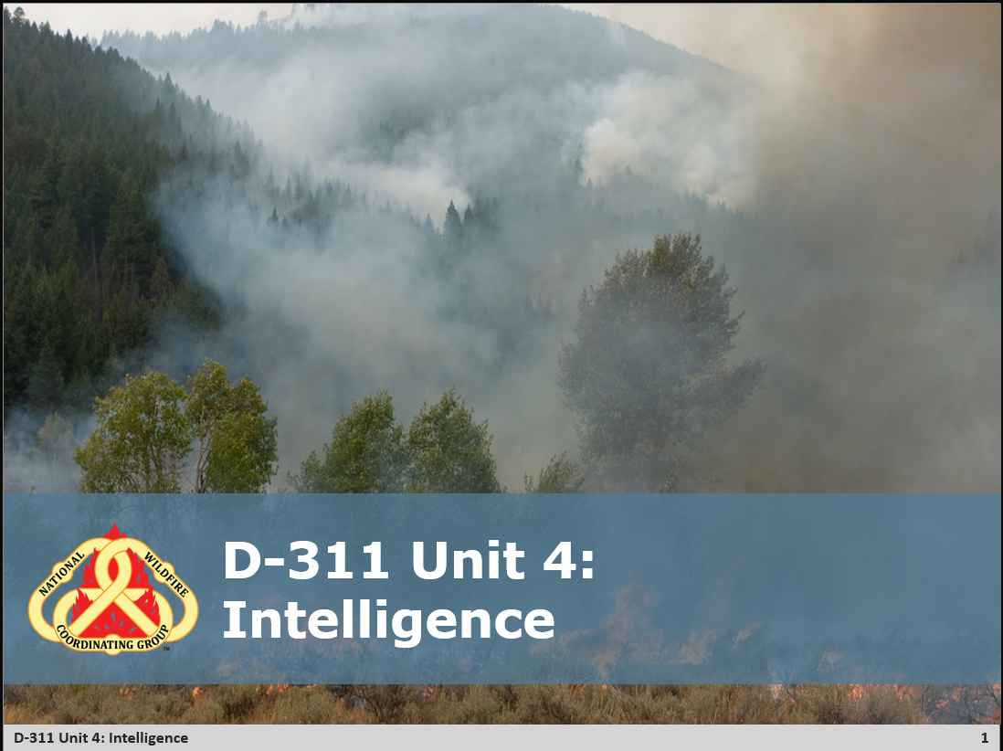
- Perform Welcomes

Slide 2
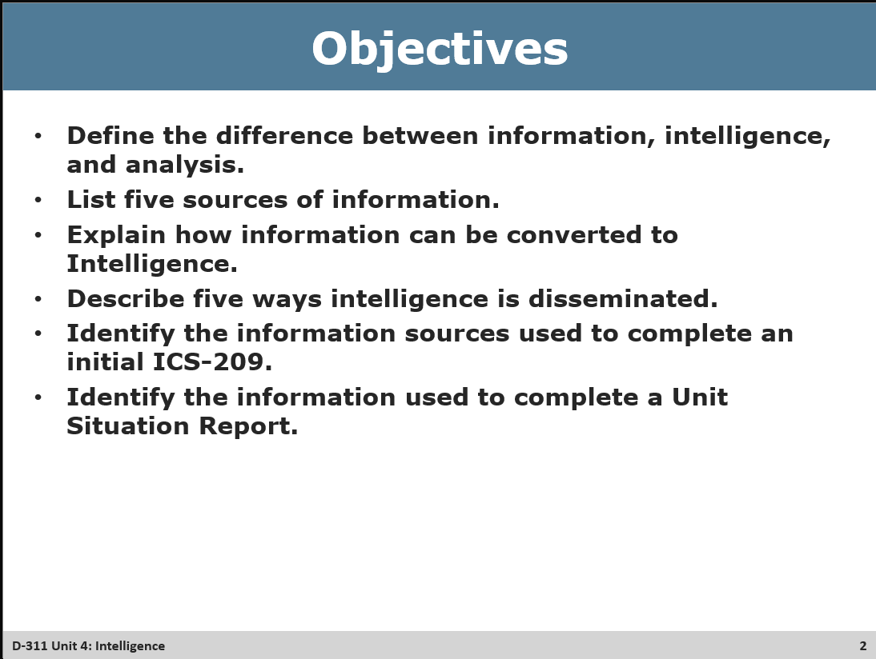
- Review Objectives

Slide 3

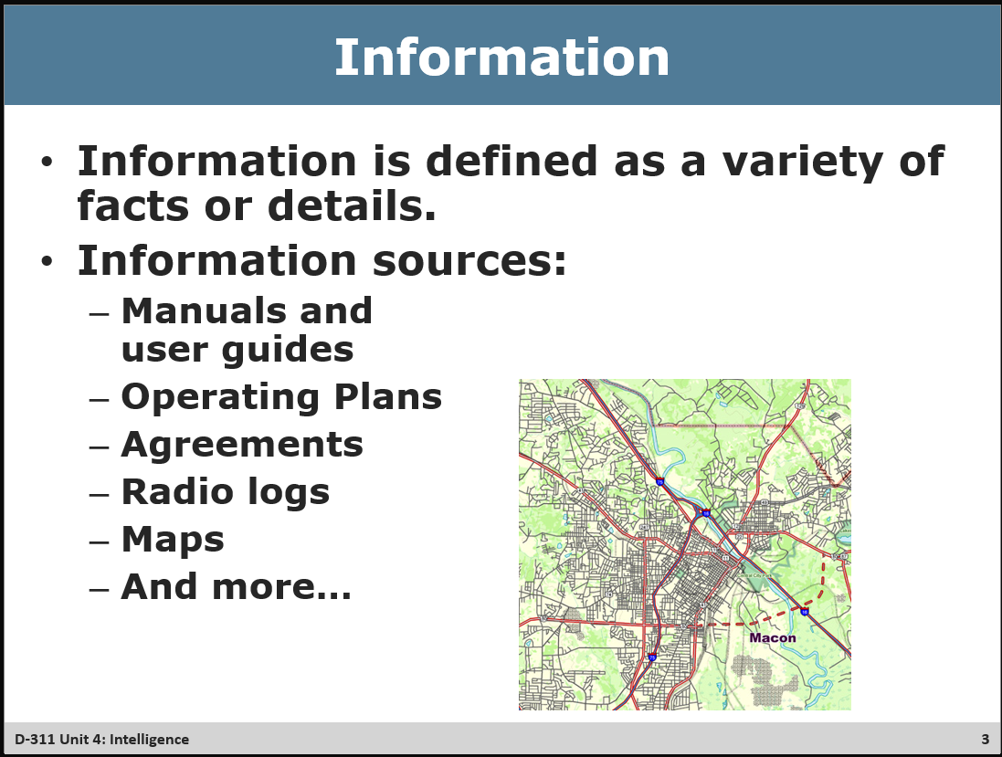
- Ask for more examples of information sources (middle of list below)
- Examples of information sources
  - Manuals, SOPs, and user guides
  - Agreements
  - Radio/CAD logs
  - Maps
  - Computer programs
  - Internet
  - Fire personnel
  - Forecaster, observations, RAWS
  - Public
  - Dispatch staff

Slide 4
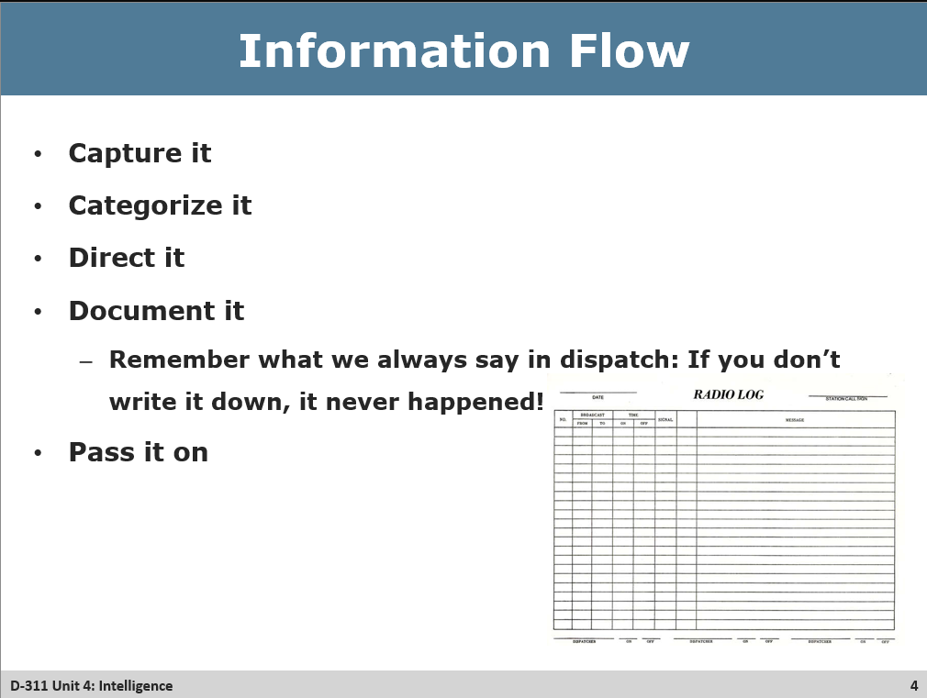
- Capture it
- Categorize it
- Direct it
- Document it
- Pass it on
- Go over a time where having documented something led to success
- How intelligence can be disseminated (Class Discussion)
  - Email
  - Websites
  - Forms, records, and reports
  - Briefings
  - Local incident and resource status reports
  - Display areas
  - Fire information centers
  - Situation reports
  - IMSR – Incident Management Situation Report

Slide 5
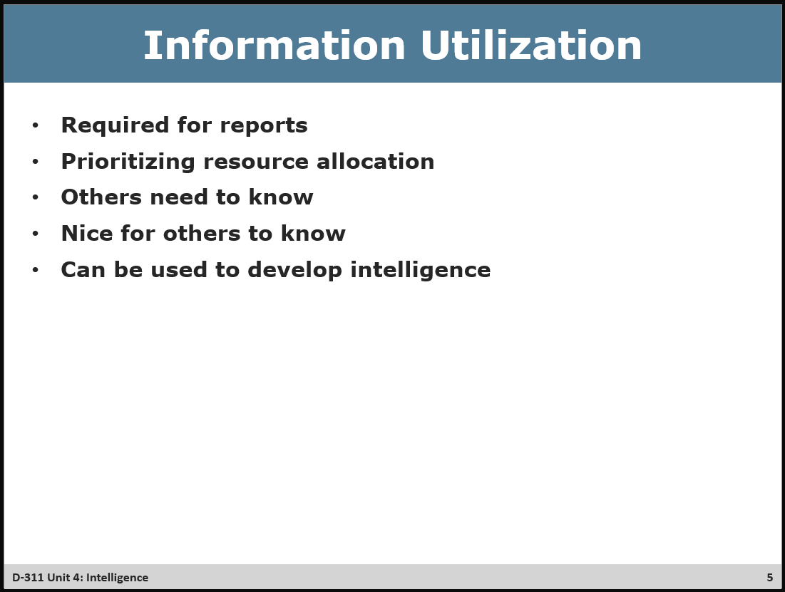
- Examples of information utilization
  - Required for reports
  - Prioritizing resource allocation
  - Information sharing
  - Can be utilized to develop intelligence

Slide 6
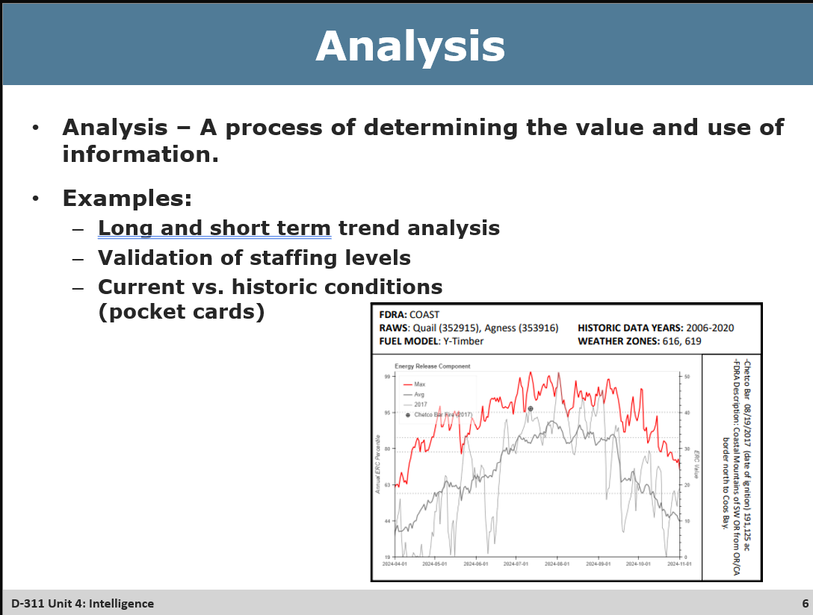
- Go over some details of a pocket card and note how it is different from and ERC Chart coming up on the next slide – how pocket cards highlight data over a range of time and compare certain fire years with large/catastrophic fires to the maximum conditions over that range.

Slide 7

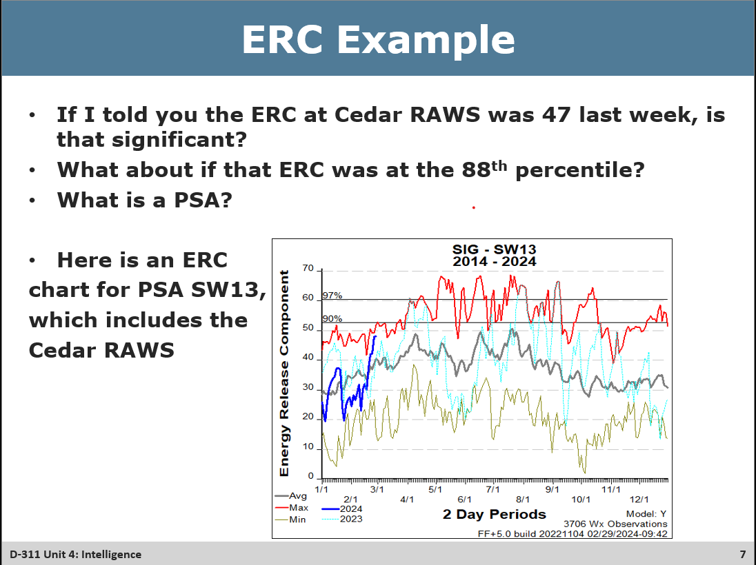
Exercise
- Review the questions with students
- Gauge when they believe that the Information has become Intelligence
- Intelligence - Information that has been analyzed for its application to the current situation
- The Pocket Card on the Slide before as well as this ERC chart can be considered intelligence products

Slide 8

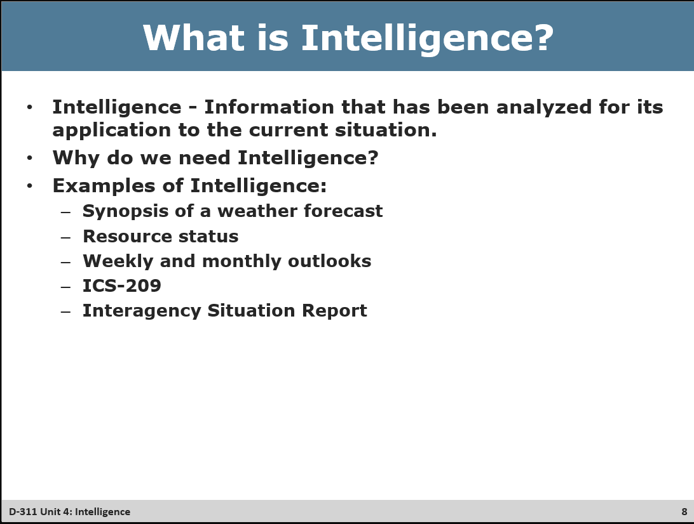
- Why do we need intelligence? (Class Discussion)
  - Local, area, and national prospective
  - Prioritizing
  - Anticipating
  - Planning
  - Decision making
- Examples of intelligence (Class Discussion)
  - Synopsis of weather forecast
  - Resource status
  - Weekly and monthly outlooks
  - ICS-209
  - Interagency situation report

Slide 9
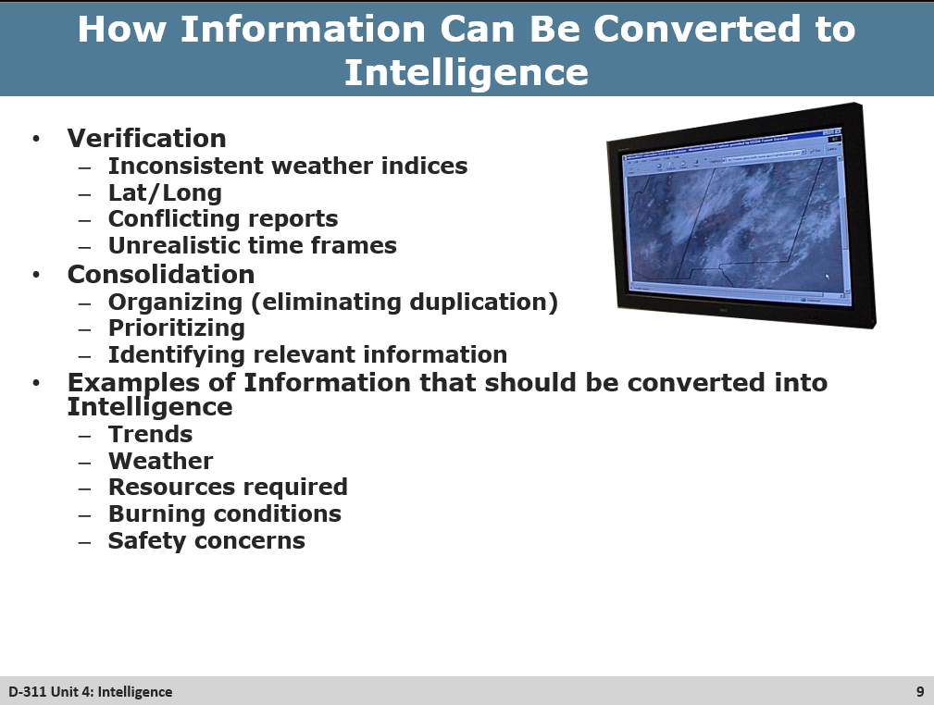
- How information can be converted to intelligence (Class discussion)
  - Verification
          - Inconsistent weather indices
          - Latitude and longitude
          - Conflicting reports
          - Unrealistic timeframes
        - Consolidation
          - Organizing
          - Prioritizing
          - Identifying relevant information
        - Trends
          - Weather
          - Resources required
          - Burning conditions
          - Safety concerns

Slide 10
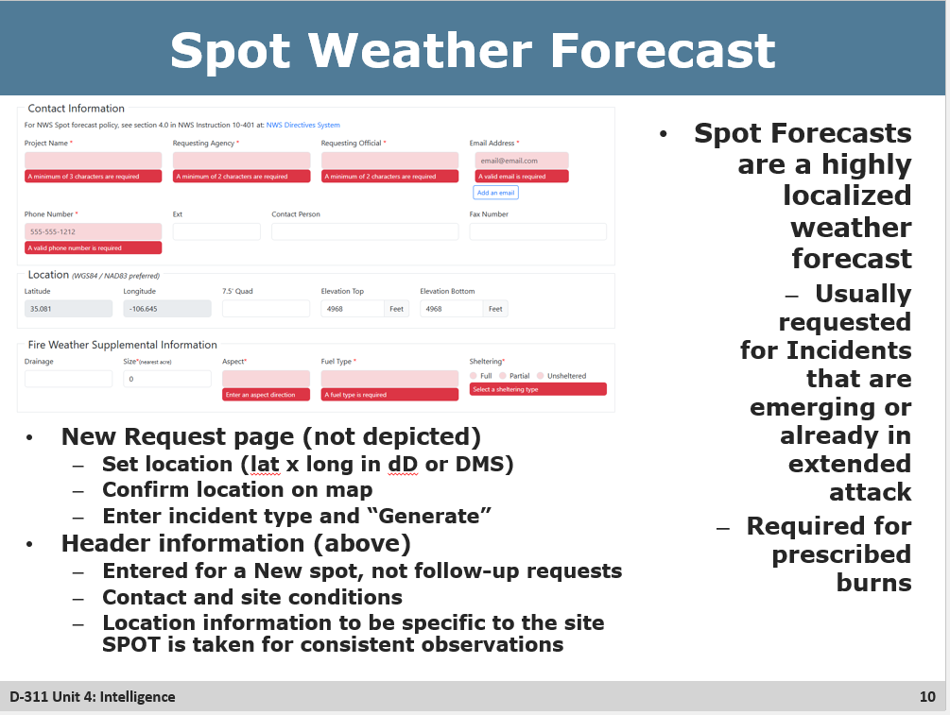
- Given the definition of a Spot forecast why might they be important
- Discuss the Header and that it is generally good for the duration of the incident

Slide 11
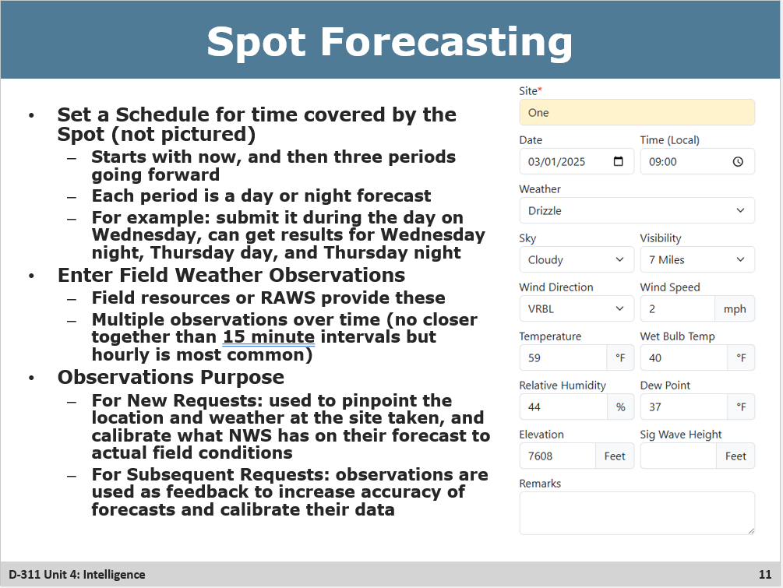
- Always select all options for the details covered (sky weather, temp, humidity… etc)
- Note that with how specific Spot Forecasts are, the further out in time the quicker they get less accurate
- Observations are technically optional, but they are strongly encouraged
  - Enter as many details as possible for each observation

Slide 12
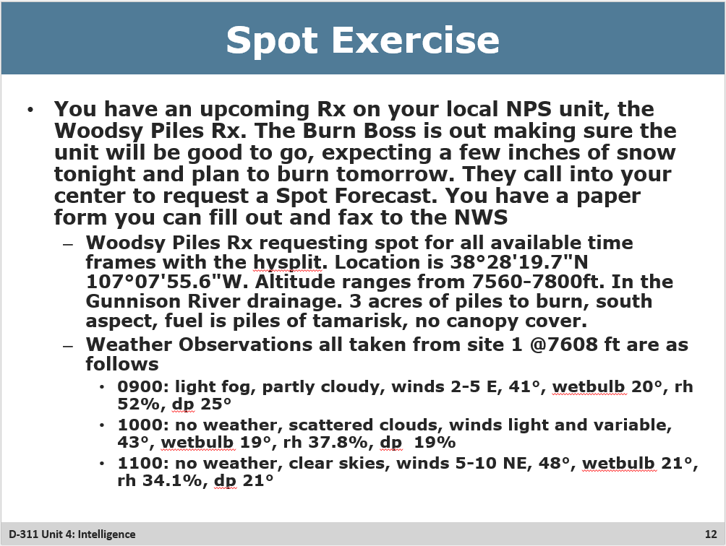

- Pass out the Spot Forecast entry sheets
  - Read the scenario… OH NO the internet is out and we have to fax the form in

Slide 13
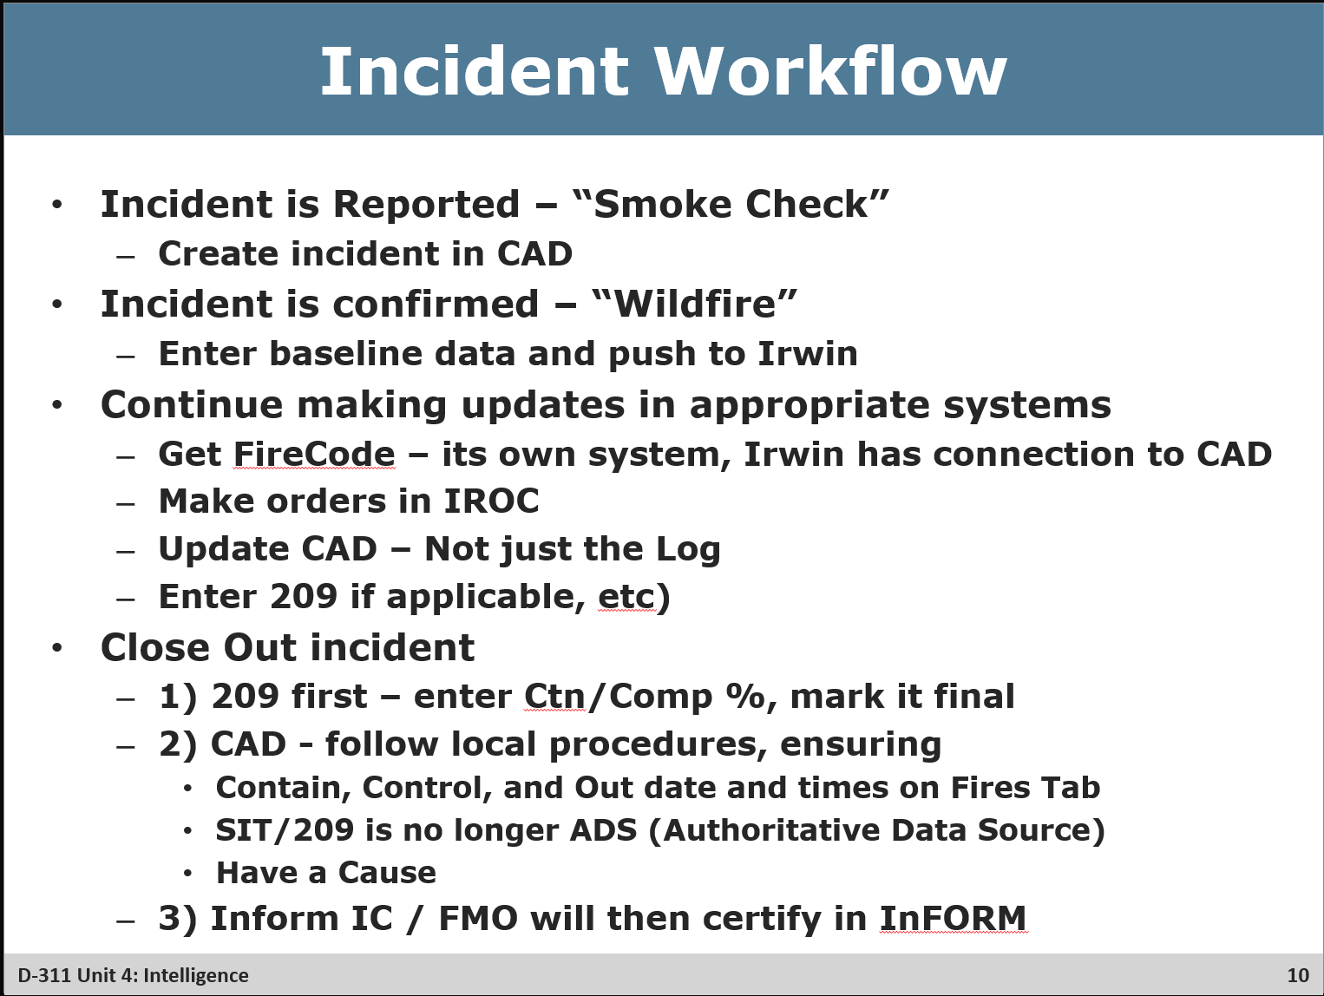

- Review the First two points, and then go over the relevant fields in WildCAD-E. Note this is an ideal flow and for many states the workflow may be different, such as cradle to grave in inform only.
- In WildCAD-E, go over the following sections, highlighting their need to get Irwin-ID and what that results in
  - WildCAD Incident Panel – Open an existing incident – (they will learn to plot a new one in the WildCAD-E unit)
    - IRWIN – Must have Incident Name, Disc. Acres, and “This center has primary responsibility” is checked. See the “IRWIN Incident” appeared
      - IRWIN Tab/ Irwin ID created
    - WildWEB – go to WildWeb and show them what can be seen on incidents
    - Fires Tab – Reading the Log is great, but Fires tab has latest info in a easily seen one-stop shop (when dispatchers keep it updated!)
    - Finance Tab – Just discuss Irwin automated the connection to “Get FireCode” and that Irwin ID had to be received for that to be possible
    - ADS - SIT 209 check box – go over this and how if the incident gets a 209, that would need to be finalized before this is unselected
- Return and close out slide noting that we are going to go into many of those systems and talk about 209s

Slide 14
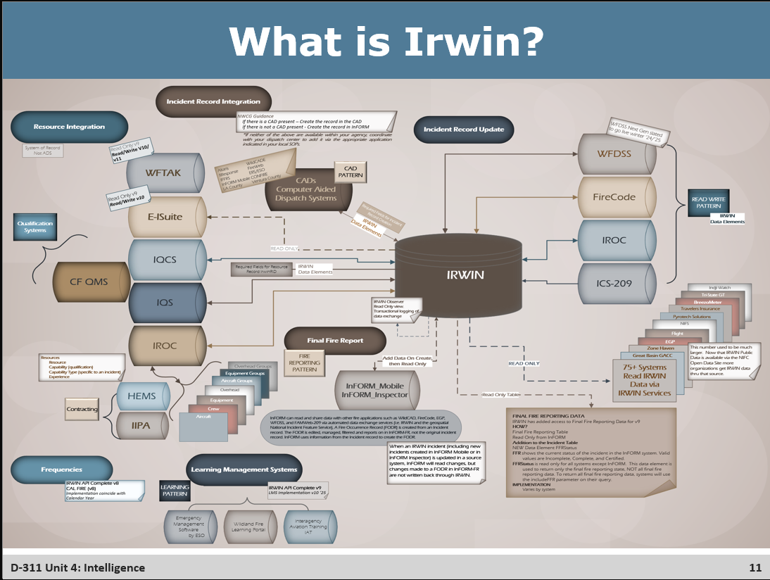
- We keep talking about Irwin, but what is it really?
- Discuss some of the systems, highlighting ones that dispatchers will work with, such as: IQCS, ICS, IROC, WFDSS, FireCode, IROC, ICS-209, InFORM

Slide 15
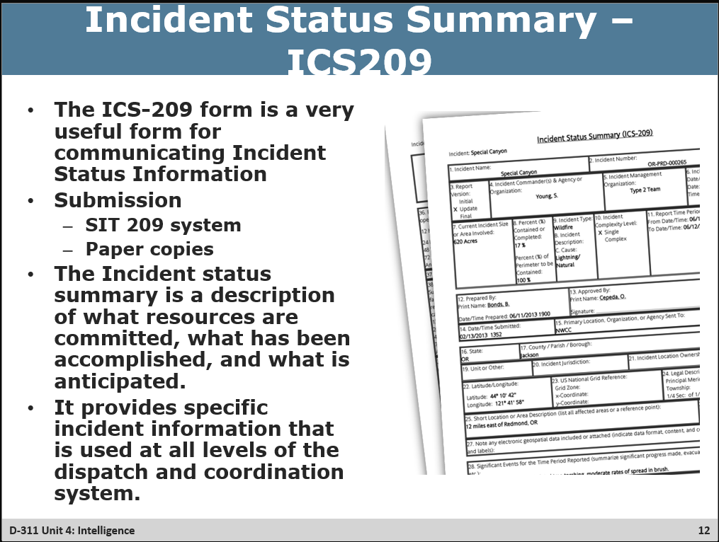
- If SIT209 is down, paper copies remain the backup – they are also good for field employees to get one started before digitizing
- The ICS209 is a description of what resources are committed, what has been accomplished, and what is anticipated
- It provides specific incident information that is used at all levels of dispatch and coordination

Slide 16
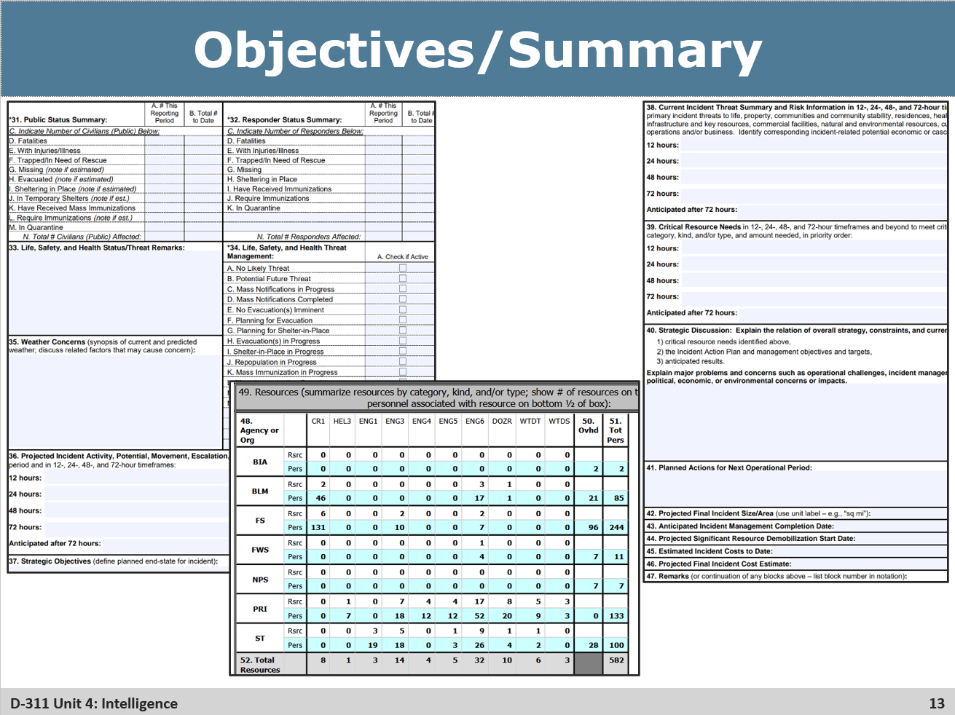
- The last slide showed a snip of what might be entered in the location summary section of the 209
- This slide shows most of the rest of the 209, discuss the safety items like responder status, threat management actions
  - how there are some sections that break it down into phases over the next 72+ hours
  - anticipated demob and ctn are super important
- All resources should be tracked by resource type, agency that provided them, and personnel on the resource.

Slide 17
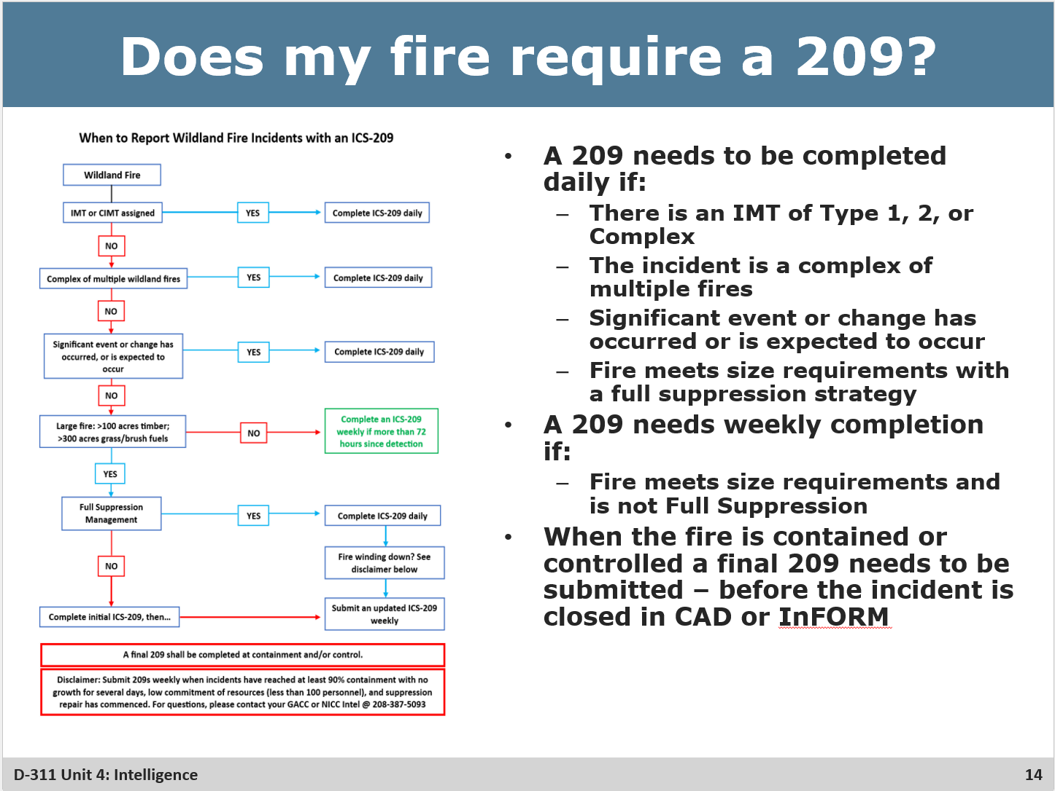
❑ Follow the flowchart
- Large Fire Criteria: 100 Acres in timber fuel models, 300 acres in grass fuel models
- Reworded: A 209 needs to be completed daily if:
  - There is an IMT of Type 1, 2, or Complex
  - The incident is a complex of multiple fires
  - Significant event or change has occurred or is expected to occur
  - Fire meets size requirements with a full suppression strategy
- A 209 needs weekly completion if:
  - Fire meets size requirements and is not Full Suppression
- When the fire is contained or controlled a final 209 needs to be submitted – before the incident is closed in CAD or InFORM
- New direction on winding down

Slide 18
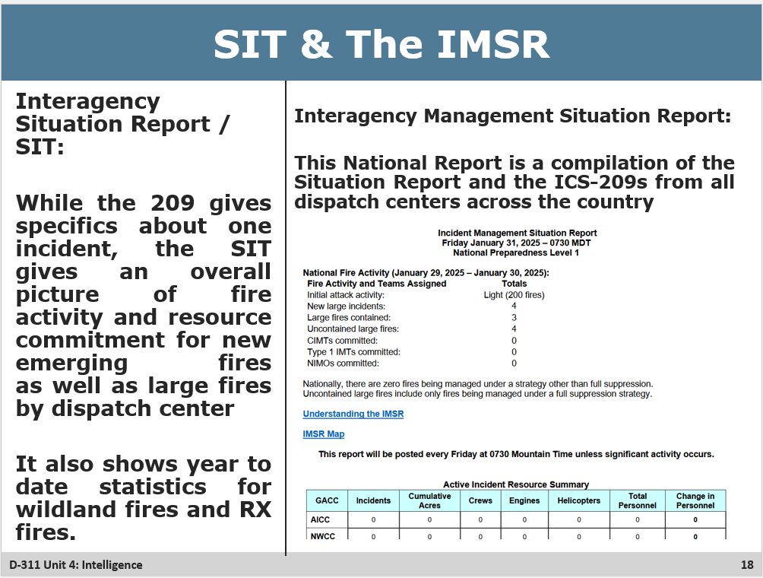
❑ Open a center in the SIT report data entry and go over the tabs. Remind students to save after every tab is entered
- Daily Fire Statistics – add new fires and acres for each type of incident, as well as local units fire danger and preparedness level
- Planned Prescribed Fires – Some GACCs use this, some do not, but the fields are relatively straightforward. Don’t forget to delete entries after the fire becomes no longer planned (ie completed or cancelled)
- Remarks – Local PL level for the Center as well as any Remarks that they wish to pass to the GACC or the NICC
- Year-to-Date Statistics – This page can be used to fix the total fires and acres if there have been changes made to fires, especially any reductions in acres. It is also useful to compare to the centers master fire log to ensure both match
- Incident Priority – In the event that there are multiple fires ongoing with a 209 for your center, the proposed priority for resources can be entered on this tab
__________________________________________________________________________________
- The SIT and 209 data are critical to the GACC, NICC, National Fire Desk for decision making purposes. The Data from these programs are used to prepare numerous reports across the country, and specifically for the Incident Management Status Report (IMSR). The frequency that the Report is published is based on amounts of activity as well as the national Preparedness Level.

Slide 19
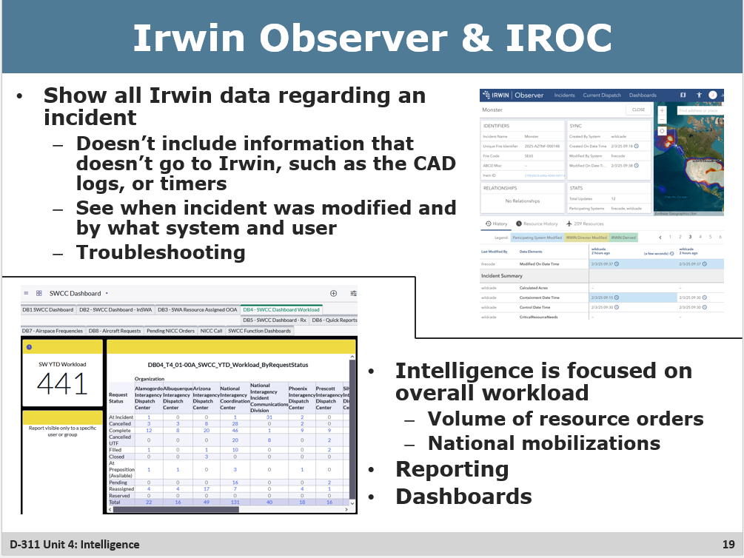

- Show all Irwin data regarding an incident
  - Doesn’t include information that doesn’t go to Irwin, such as the CAD logs or timers
- See when incident was modified and by what system and user
- Originally designed by the irwin team for their ability to troubleshoot problems, and quickly became a useful tool for the dispatch community
- Has the ability to download a spreadsheet of all Irwin Data for an incident or set of incidents
_____________________________________________________________________________
- IROC (Interagency Resource Ordering Capability) is the primary method by which resources are ordered and mobilized when leaving their home unit. It is the main focus of an expanded dispatch center as well as used regularly at IA, AC, and Logistics desks.
- Intelligence, Logistics, and Support folks will utilize IROC for tracking resources, estimating workload and writing reports more than for actually mobilizing and demobilizing resources.
- Reports written in IROC can be used to deliver Intelligence themselves, or comprise a dashboard such as that displayed on this slide

Slide 20

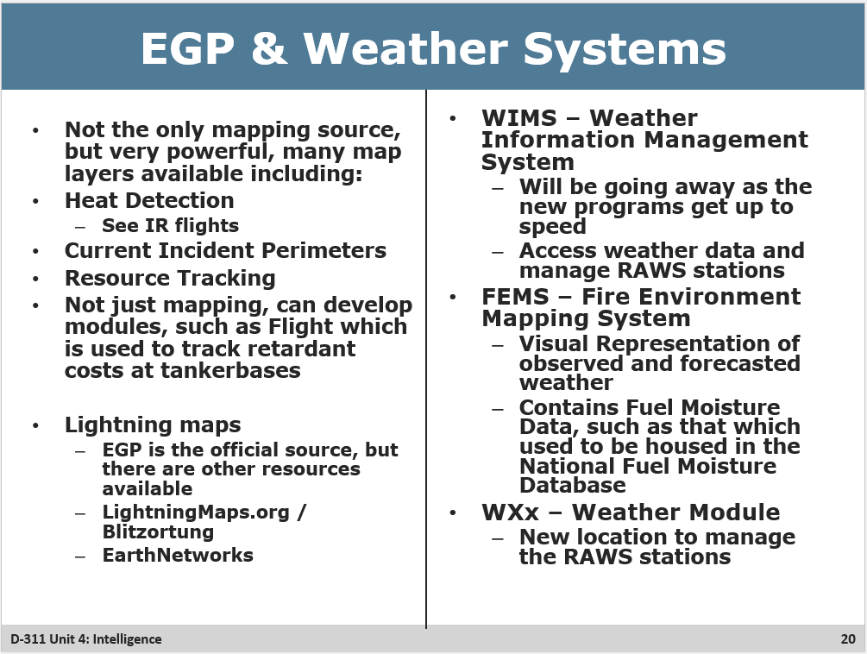
- Also via FamAuth, Its not the only mapping source, but very powerful
- Heat Detection - Ability to see IR flights; Current Incident Perimeters; Resource Tracking
- Not just mapping, can develop modules, such as Flight which is used to track retardant costs at tankerbases
- Lightning maps
  - EGP is the official source, but there are other resources available
  - LightningMaps.org / Blitzortung
  - EarthNetworks

______________________________________________________________________
❑ See if the class knows what a RAWS is
- WIMS – Weather Information Management System
  - Will be going away as the new programs get up to speed
  - Access weather data and manage RAWS stations
- FEMS – Fire Environment Mapping System
  - Visual Representation of observed and forecasted weather
  - Contains Fuel Moisture Data, such as that which used to be housed in the National Fuel Moisture Database
- WXx – Weather Module
  - Newer location to manage the RAWS stations

Slide 21
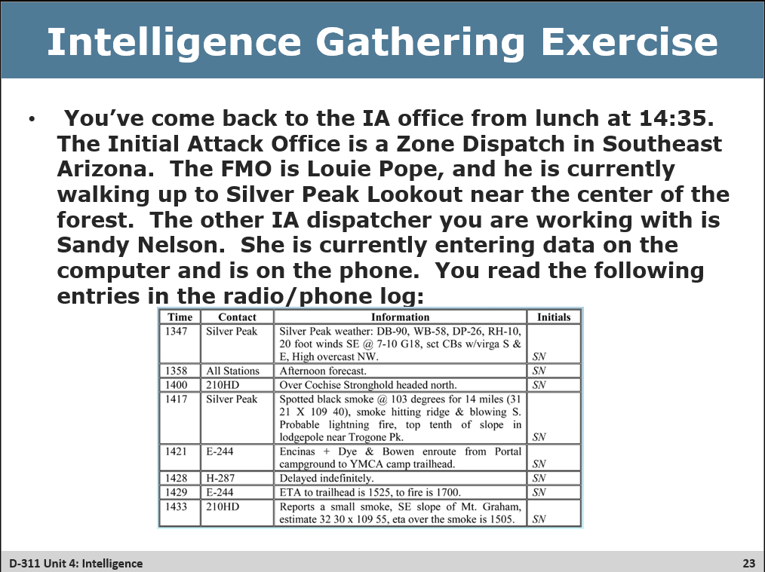
- Funny thing dispatcher not getting Lunch until 1400
❑ Review the scenario

Slide 22
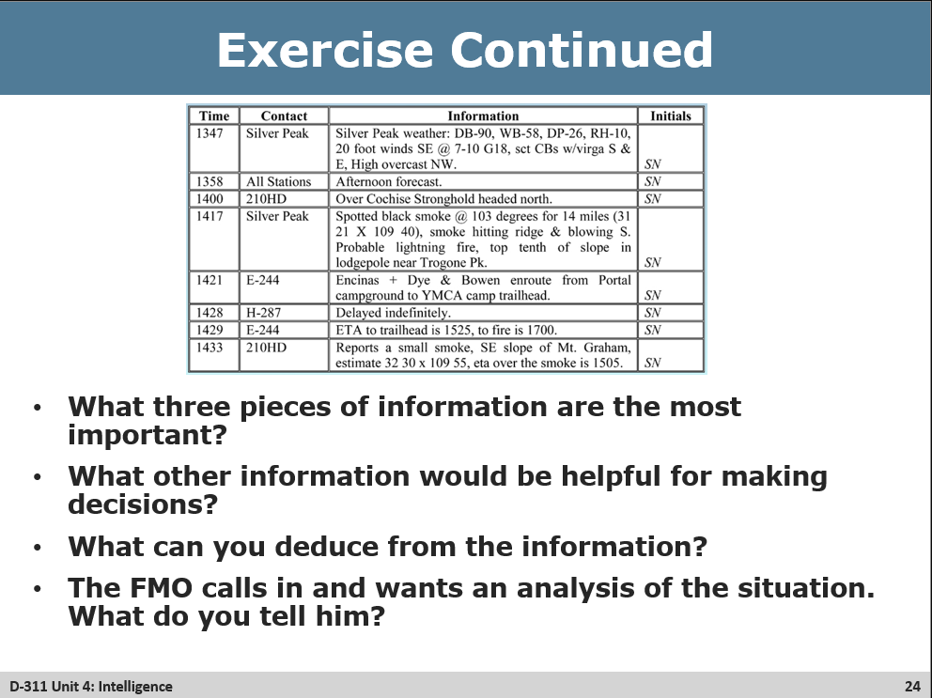
- Note this the same Radio log from last slide, but useful for the questions
❑ Review Questions class discussion
- Important information would include location, winds (and weather in general), character of the smoke, fuels, confirmation by a second source
- Other good info to have: confirmed location from resource on scene, full size up
- Deductions: Lodgepole is a stand replacement tree type, so likely a timber fuel model, 100 acre threshold for an ICS-209. Spread potential moderate due to location on slope and weather, but sky weather is promising.
- FMO Report: Located X miles from Y city on Mt Graham with low winds and dry conditions but some overcast nearby. Fuel is Lodgepole near the top of the hill, 210HD confirmed lookout’s report still a small smoke and first resource on scene soon eta 1505.

